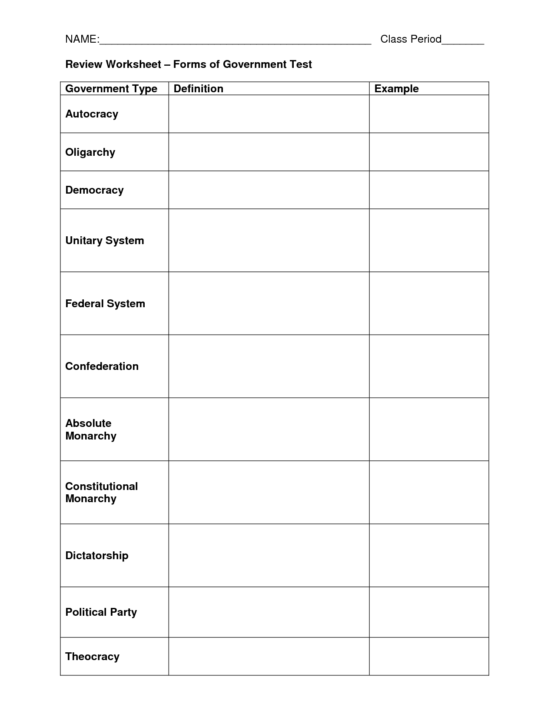

state where one person holds all power

Dictatorship and monarchy

Ancient Rome

state where a few people hold all power

Parliamentary and presidential

state where citizens hold political power

United Kingdom, Cuba

central government makes all laws for the entire country

US, Germany, Russia, Venezuela. Mexico, Canada, Australia

power is divided between federal, regional & local governments

European Union, British Commonwealth

group of independent states join together and give limited powers to a common govt.

Saudi Arabia

state ruled by king/queen who inherits power and has complete power over people

United Kingdom. Canada, Australia

state ruled by king/queen who inherits power and has little power over people

Cuba

state where one person holds all power